Flickr Eye

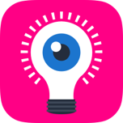

FilckrEye - Vision assistant for the Blind and people with low vision...

Flickr Eye IOS application has been developed specifically for the blind or people with low vision. Utilizing the potential of Flickr vision technology and text to speech libraries, this app is intended to assist blind people with everyday tasks, increase independence and generally make things easier.

Flickr Eye allows users with low vision to take a picture of their surrounding by a single click anywhere on their IPhone. The picture is atomically uploaded to the Flickr vision cloud and processed in real time.

The response containing detailed content of the image is sent back to the user's IPhone with a response time of less than 1sec.

**Please click on the following link to se a demonstration video**

[Demo Video.mov](https://www.dropbox.com/s/8ug9mugj5jubwho/Flicker%20Eye%20movie%202%20small1.mov?dl=0)

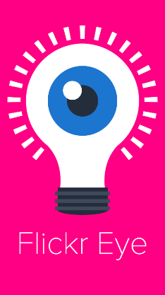 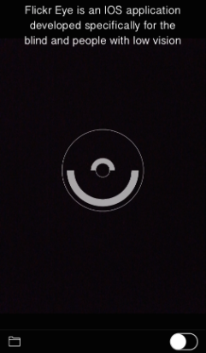 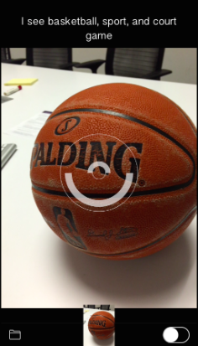 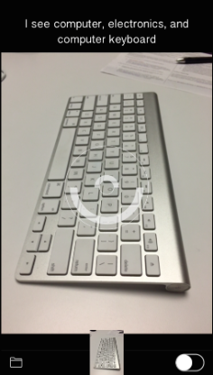 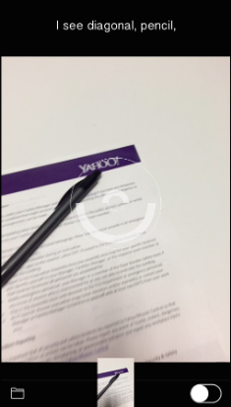

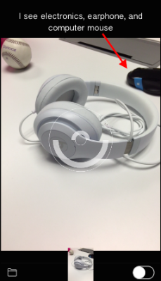 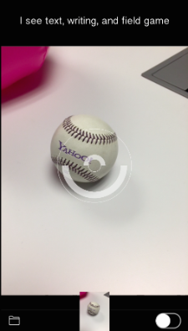 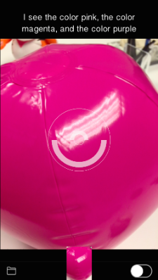 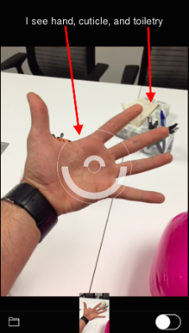

The information of the image content is processed based on accuracy-probability and the keywords/autotags are accurate more than 80% of the time. The result is spoken (text to speech) to the user.

The result is: “I see a basketball”

There are no other applications on the apps store today that do this with computer vision technology. Most of the eye-camera solutions are crowd-sourced solution. That basically means that it is really people behind the scene that analyze the image and send back image content information. The response time for these applications can be up to 20-30sec.

Thanks to the Flickr vision technology and the fact that it has analyzed over 10 billion Flickr images, we can achieve the same thing with a high accuracy in less then 1sec.

***There should not be any profit or revenue strategies tied to this project. This idea, application, technology, and solution will now and forever be offered totally free of charge!***